Chapter Title Level 1
The quick brown fox jumps over the lazy dog. The quick brown fox jumps over the lazy dog. The quick brown fox jumps over the lazy dog. The quick brown fox jumps over the lazy dog. The quick brown fox jumps over the lazy dog. The quick brown fox jumps over the lazy dog. The quick brown fox jumps over the lazy dog. The quick brown fox jumps over the lazy dog. The quick brown fox jumps over the lazy dog. The quick brown fox jumps over the lazy dog.
Section Level 2
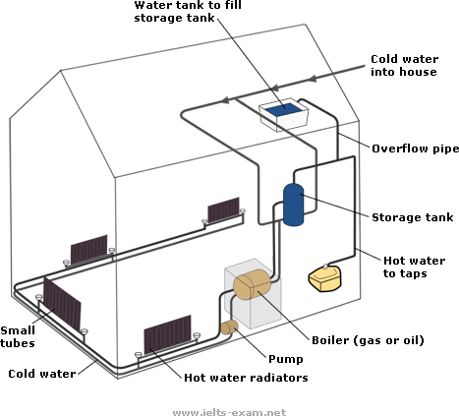
How a central heating system in a house works
The quick brown fox jumps over the lazy dog. The quick brown fox jumps over the lazy dog. The quick brown fox jumps over the lazy dog. The quick brown fox jumps over the lazy dog. The quick brown fox jumps over the lazy dog.
Section Level 3
The quick brown fox jumps over the lazy dog. The quick brown fox jumps over the lazy dog. The quick brown fox jumps over the lazy dog. The quick brown fox jumps over the lazy dog. The quick brown fox jumps over the lazy dog. The quick brown fox jumps over the lazy dog. The quick brown fox jumps over the lazy dog. The quick brown fox jumps over the lazy dog. The quick brown fox jumps over the lazy dog. The quick brown fox jumps over the lazy dog.
Section Level 2
The quick brown fox jumps over the lazy dog. The quick brown fox jumps over the lazy dog. The quick brown fox jumps over the lazy dog. The quick brown fox jumps over the lazy dog. The quick brown fox jumps over the lazy dog. The quick brown fox jumps over the lazy dog. The quick brown fox jumps over the lazy dog. The quick brown fox jumps over the lazy dog. The quick brown fox jumps over the lazy dog.
Section Level 3
The quick brown fox jumps over the lazy dog. The quick brown fox jumps over the lazy dog. The quick brown fox jumps over the lazy dog. The quick brown fox jumps over the lazy dog. The quick brown fox jumps over the lazy dog. The quick brown fox jumps over the lazy dog.
Quotation. Quotation. Quotation. Quotation. Quotation. Quotation. Quotation. Quotation. Quotation. Quotation. Quotation. Quotation. Quotation. Quotation. Quotation. Quotation. Quotation. Quotation. Quotation. Quotation. Quotation. Quotation. Quotation. (Quotation source)
Section Level 2
Country | Population | Irrigated land | Water consumption per person
Brazil | 176 million | 26,500 km² | 359 m³
Democratic  Republic  of Congo | 5.2 million | 100 km² | 8 m³
Differences in agriculture consumption in some areas of the world
The quick brown fox jumps over the lazy dog. The quick brown fox jumps over the lazy dog. The quick brown fox jumps over the lazy dog. The quick brown fox jumps over the lazy dog. The quick brown fox jumps over the lazy dog.
Section Level 3
The quick brown fox jumps over the lazy dog. The quick brown fox jumps over the lazy dog. The quick brown fox jumps over the lazy dog. The quick brown fox jumps over the lazy dog. The quick brown fox jumps over the lazy dog. The quick brown fox jumps over the lazy dog. The quick brown fox jumps over the lazy dog. The quick brown fox jumps over the lazy dog. The quick brown fox jumps over the lazy dog. The quick brown fox jumps over the lazy dog.
Section Level 2
The quick brown fox jumps over the lazy dog. The quick brown fox jumps over the lazy dog. The quick brown fox jumps over the lazy dog. The quick brown fox jumps over the lazy dog. The quick brown fox jumps over the lazy dog. The quick brown fox jumps over the lazy dog. The quick brown fox jumps over the lazy dog. The quick brown fox jumps over the lazy dog. The quick brown fox jumps over the lazy dog.
Quotation. Quotation. Quotation. Quotation. Quotation. Quotation. Quotation. Quotation. Quotation. Quotation. Quotation. Quotation. Quotation. Quotation. Quotation. Quotation. Quotation. Quotation. Quotation. Quotation. Quotation. Quotation. Quotation. (Quotation source)
Section Level 3
The quick brown fox jumps over the lazy dog. The quick brown fox jumps over the lazy dog. The quick brown fox jumps over the lazy dog. The quick brown fox jumps over the lazy dog. The quick brown fox jumps over the lazy dog. The quick brown fox jumps over the lazy dog.

