Chapter Title Level 1
The quick brown fox jumps over the lazy dog. The quick brown fox jumps over the lazy dog. The quick brown fox jumps over the lazy dog. The quick brown fox jumps over the lazy dog. The quick brown fox jumps over the lazy dog. The quick brown fox jumps over the lazy dog. The quick brown fox jumps over the lazy dog. The quick brown fox jumps over the lazy dog. The quick brown fox jumps over the lazy dog. The quick brown fox jumps over the lazy dog.
Section Level 2
The quick brown fox jumps over the lazy dog. The quick brown fox jumps over the lazy dog. The quick brown fox jumps over the lazy dog. The quick brown fox jumps over the lazy dog. The quick brown fox jumps over the lazy dog.
Section Level 3
The quick brown fox jumps over the lazy dog. The quick brown fox jumps over the lazy dog. The quick brown fox jumps over the lazy dog. The quick brown fox jumps over the lazy dog. The quick brown fox jumps over the lazy dog. The quick brown fox jumps over the lazy dog. The quick brown fox jumps over the lazy dog. The quick brown fox jumps over the lazy dog. The quick brown fox jumps over the lazy dog. The quick brown fox jumps over the lazy dog.
Section Level 2
Number of children ever born, Women aged 40–44 years
 |  |  |  |  | Four or
 |  | One | Two | Three | more
 | None | child | children | children | children
year | % | % | % | % | %
2006 | 15.9 | 13.2 | 38.3 | 21.5 | 11.0
1996 | 12.8 | 11.3 | 38.2 | 24.6 | 13.1
1986 | 9.7 | 8.7 | 35.6 | 27.0 | 18.9
1981 | 8.5 | 7.6 | 29.0 | 27.4 | 27.6

Number of children ever born
The quick brown fox jumps over the lazy dog. The quick brown fox jumps over the lazy dog. The quick brown fox jumps over the lazy dog. The quick brown fox jumps over the lazy dog. The quick brown fox jumps over the lazy dog. The quick brown fox jumps over the lazy dog. The quick brown fox jumps over the lazy dog. The quick brown fox jumps over the lazy dog. The quick brown fox jumps over the lazy dog.
Section Level 3
The quick brown fox jumps over the lazy dog. The quick brown fox jumps over the lazy dog. The quick brown fox jumps over the lazy dog. The quick brown fox jumps over the lazy dog. The quick brown fox jumps over the lazy dog. The quick brown fox jumps over the lazy dog.
Quotation. Quotation. Quotation. Quotation. Quotation. Quotation. Quotation. Quotation. Quotation. Quotation. Quotation. Quotation. Quotation. Quotation. Quotation. Quotation. Quotation. Quotation. Quotation. Quotation. Quotation. Quotation. Quotation. (Quotation source)
Section Level 2
The quick brown fox jumps over the lazy dog. The quick brown fox jumps over the lazy dog. The quick brown fox jumps over the lazy dog. The quick brown fox jumps over the lazy dog. The quick brown fox jumps over the lazy dog.
Section Level 3
The quick brown fox jumps over the lazy dog. The quick brown fox jumps over the lazy dog. The quick brown fox jumps over the lazy dog. The quick brown fox jumps over the lazy dog. The quick brown fox jumps over the lazy dog. The quick brown fox jumps over the lazy dog. The quick brown fox jumps over the lazy dog. The quick brown fox jumps over the lazy dog. The quick brown fox jumps over the lazy dog. The quick brown fox jumps over the lazy dog.
Section Level 2
The quick brown fox jumps over the lazy dog. The quick brown fox jumps over the lazy dog. The quick brown fox jumps over the lazy dog. The quick brown fox jumps over the lazy dog. The quick brown fox jumps over the lazy dog. The quick brown fox jumps over the lazy dog. The quick brown fox jumps over the lazy dog. The quick brown fox jumps over the lazy dog. The quick brown fox jumps over the lazy dog.
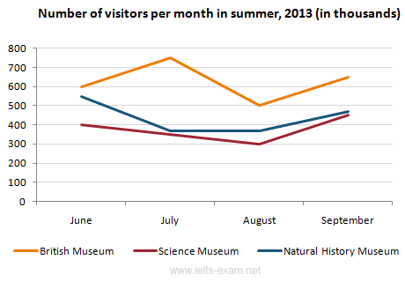
Number of visitors per month in summer
Quotation. Quotation. Quotation. Quotation. Quotation. Quotation. Quotation. Quotation. Quotation. Quotation. Quotation. Quotation. Quotation. Quotation. Quotation. Quotation. Quotation. Quotation. Quotation. Quotation. Quotation. Quotation. Quotation. (Quotation source)
Section Level 3
The quick brown fox jumps over the lazy dog. The quick brown fox jumps over the lazy dog. The quick brown fox jumps over the lazy dog. The quick brown fox jumps over the lazy dog. The quick brown fox jumps over the lazy dog. The quick brown fox jumps over the lazy dog.

